**ETHERNET CONTROLLER KIT**

This circuit is an ETHERNET controller I use the PIC18F452 and the mikroC C Compiler. We use also the JAVA SCRIPT information you can get from www.w3school.com I Control 8 outputs throw the WEB and transfer time information also.

I use 3 timer and 3 buffers each one has its own time Start Stop and the outputs will take the buffer BIN value

BUFFER 1 -> TIMER 1

BUFFER 2 -> TIMER 2

BUFFER 3 -> TIMER 3

I do all the adjustment throw the WEB. I also test it to transfer temperature information using DS1820 temp. Sensor. I Set time-date throw the WEB

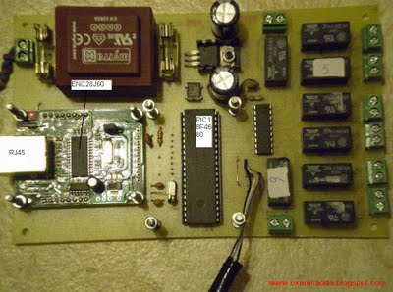

**Features:**

1. Display time (DS1307), with backup battery.

2. Control 8 outputs

3. 3 timers to control the outputs each timer has separate time for start and stop

4. All the adjustment throw the WEB

**Schematic:**

